Add Sublet Labor to an Existing Repair Order: This topic covers using ROM to add sublet labor to an existing repair order.

Access an Existing Repair Order: If the screen is blank to start with, either type the RO number in the Repair Order field or use the Search to look it up. If you already have an RO open, you will need to click New Repair Order to clear the screen and open the RO you want to add the charges to.

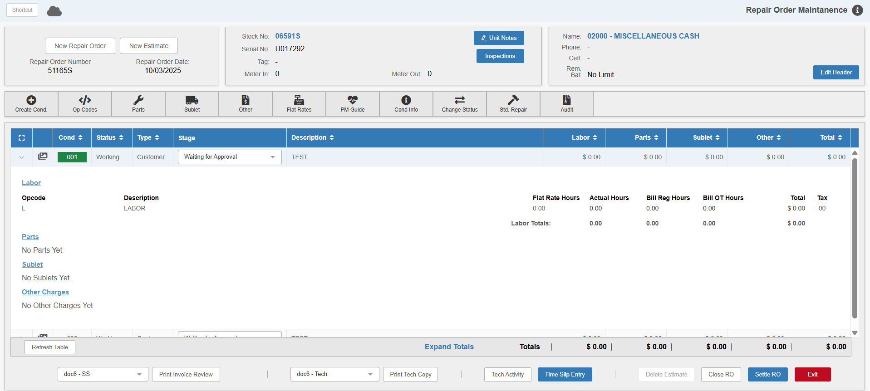

Adding Sublet: Expand the condition you want to add the labor to. Click Sublet to open the following window:

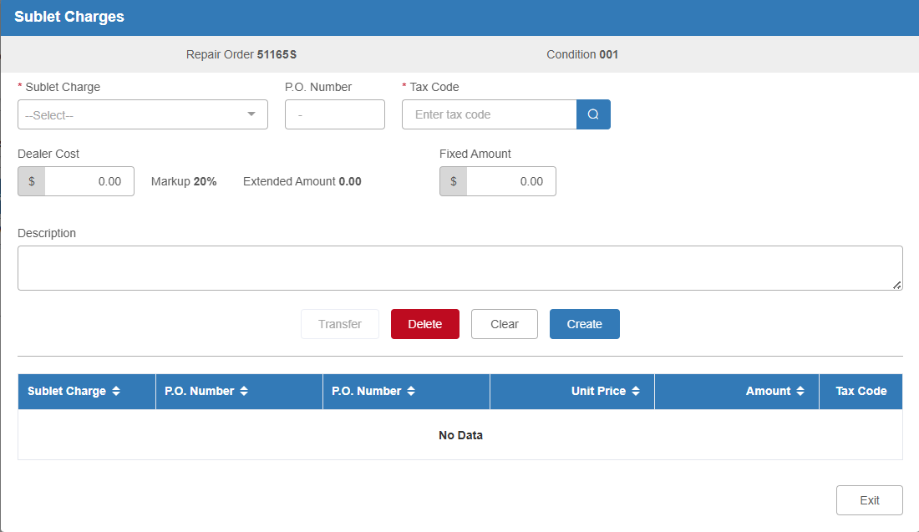

Sublet Charge: Enter the Sublet code or use the drop-down menu to select it from the list.

PO Number: Fill in this field as needed.

Tax Code: The tax code is read from the Customer Master, but can be changed as necessary. If the customer does not have a default tax code set, you will need to enter one in order to add the charge.

Dealer Cost/Fixed Amount: Enter this value if provided and system will handle mark-up -OR- enter a Fixed Amount to charge for sublet.

Description: Enter an extended description of the sublet labor if desired.

Save: Click this button to save the sublet labor charge.

You can add as many charges as you want in this screen. They will show in the grid in the bottom half as they are added.

Exit: Click this button when you are done adding sublet charges. You will be returned to the main screen, and any charges you added will appear in the Sublet section of the condition’s details.

